|  |  |
| --- | --- |
| **Title of the document** | **IJCore Double-take Physical Failover test procedure** |
| **Reference** | **GIS-I-LSG-3799** |
| **Purpose** | Physical Failover Test and Failback procedure using Double-take software on IJCore servers. |
| **Scope** | • IJCore Sites worldwide  • To be used by Local IT with the support of 9TECHSF team |
| **Related documents** | GIS-I-LSG-3768 Double-Take Physical Failover test procedure for MII |
| **Issue n°** | 01 |
| **Description of changes** | Issue 01 – 1.12.2015 – Document creation |
| **Cancels and replaces** |  |
| **Owner** | Jiri SEMRAD (IJCore Technical CC Coordinator) |
| **Approved by** | Heiko KIRCHNER (Back Office Manager) |

Contents

1 General information 3

1.1 Overview 3

1.2 Brief description of Failover steps 3

1.3 Used terms 4

1.4 Periodicity 4

1.5 Expected Timeline 5

1.6 Pre-requisites needed 5

1.7 Using Double-take console 6

2 FAILOVER to backup hardware 8

3 Tests to be done after Failover 11

4 Failback procedure: Re-creating replica after Failover 12

5 Summary 21

6 Possible issues 22

# General information

## Overview

**About this document**

This document provides information about Physical Test Failover procedure and replica re-creation using Double-take software.

**Intended audience**

This document is intended for Local Support IT to understand and be able to perform Physical Test Failover to backup hardware and re-configure replica. This document is written for experienced Windows administrators who are familiar with Microsoft technology and have a basic understanding of how Double-Take works.

**GIS School training for failover available**

You should attend at GIS School Failover test and get the certification after you passed the session with GIS trainer.

**Physical Failover Test**

**Course code name:** FailOver-Phytest

**Objective:** you will see how proceeding Physical Failover Test and Failback with Double-Take.

**Target Population:** Local IT

**Duration:** 3.5 Hours

**Training planning:** this training is located under the GIS Domain

## Brief description of Failover steps

The procedure is available for all systems using DoubleTake as high availability solution.

1. Check that replication job is in good state.
2. Stop IJCore application correctly. Shutdown primary IJCore server
3. Initiate the Failover process via Double-take console
4. After the Failover, another correct reboot of the machine is needed (new HW detected)
5. Test that IJCore works properly
6. Migrate VRA machine
7. Re-create the replication job in Double-take

## Used terms

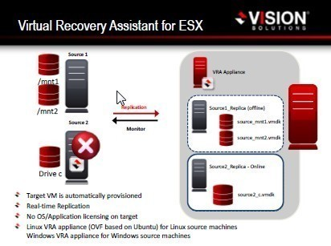

**Double-take software (DT)** – Vision Solutions company software for hardware failover purposes.

**Production IJCore Server (IJCore)** – Server where IJCore application is running, usually named XXSID**IJC0001** – i.e. USSMVIJC0001

**Virtual Recovery Appliance (VRA)** – Windows server machine that takes care about the replication process itself. Usually named XXSID**IJC0002** – i.e. USSMVIJC0002 – **There is no IJCore installed on this server!**

**IJCore Server replica (IJCore_replica)** – Complete cold backup of **IJCore** server, created by Double-take. Usually named XXSIDIJC0001_replica, - i.e. USSMVIJC0001_replica

**Primary ESX server (Primary ESX)** – Physical ESX server hosting **Production IJCore server**

**Backup ESX server (Backup ESX)** – Physical ESX server hosting **Virtual Recovery Appliance** and **IJCore Server replica**

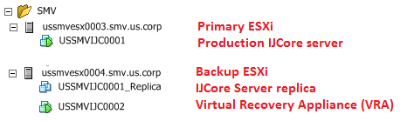

## Periodicity

Physical test failover has to be done every 6 months.

## Expected Timeline

|  |  |  |  |  |  |  |
| --- | --- | --- | --- | --- | --- | --- |
|  | action | Failover test OK | | Failover test NOK | | |
| estimated | total | estimated | total | |
| a) | Stop IJCore, Shutdown primary server | 5 - 10 min | ≤ 10 min | 5 - 10 min | | ≤ 10 min |
| b) | Initiate the failover process via DT console | 10 - 20 min | ≤ 30 min | 10 - 20 min | | ≤ 30 min |
| c) | Reboot Server | 5 - 10 min | ≤ 40 min | 5 - 10 min | | ≤ 40 min |
| d) | Check IJCore | 15 - 30 min | ≤ 70 min | 15 - 30 min | | ≤ 70 min |
| h) | Shut down the server |  |  | 5 - 10 min | | ≤ 80 min |
| i) | Start the old production server |  |  | 10 - 20 min | | ≤ 100 min |
| j) | Recreate Job in Doubletake |  |  | 5 min | | ≤ 105 min |
|  | IJCore SYSTEM AVAILABLE (not protected) |  | ≤ 70 min |  | | ≤ 105 min |
| e) | Migrate VRA machine | 15 – 45 min | ≤ 115 min |  | |  |
| f) | Recreate Job in Doubletake | 5 min | ≤ 120 min |  | |  |
| g) | Wait for replication of server | 60 - 180 min | ≤ 300 min |  | |  |
|  | IJCore SYSTEM AVAILABLE (fully protected) |  | ≤ 300 min |  | |  |

|  |  |  |
| --- | --- | --- |
| Size | Estimated duration of replication (minutes) (with gigabit network)* | |
| from | to |
| 60 GB | 90 | 120 |
| 90 GB | 120 | 150 |
| 120 GB | 150 | 180 |

**\*Note that if you are on 100MBit network, failover will take much more time**

## Pre-requisites needed

* + Checklist is a separate XLS document needs to be filled by Local IT and sent to 9TECH_IJCore team ([9Tech_IJCORE@faurecia.com](mailto:9Tech_IJCORE@faurecia.com)) before creating RFC for Failover test.



* + **Without filled checklist the RFC won’t be approved.**

## Using Double-take console

To use Double-take console go to RDP of VRA server - IJC0002. DT console can be found via Start menu. Console will be empty after first start

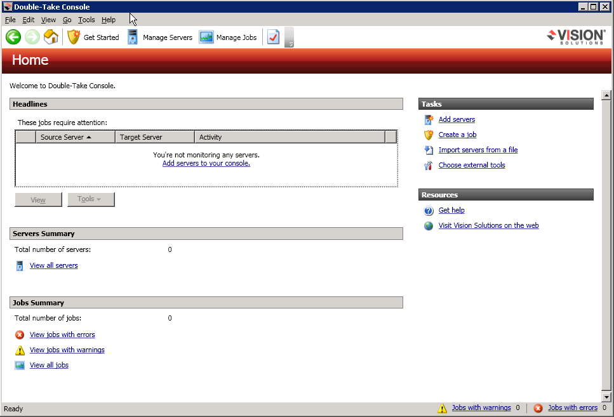

To add your servers, go to Manage Servers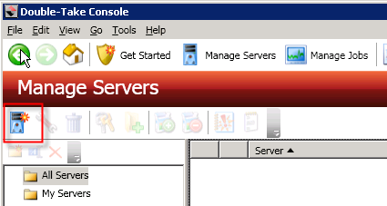

**Click Add servers icon**

Fill in required info, like server name and credentials – **use DTAdmin user** (knowledge of password to this account is part of Failover checklist). Use short server name (USSMVIJC0001). Click Add for each server

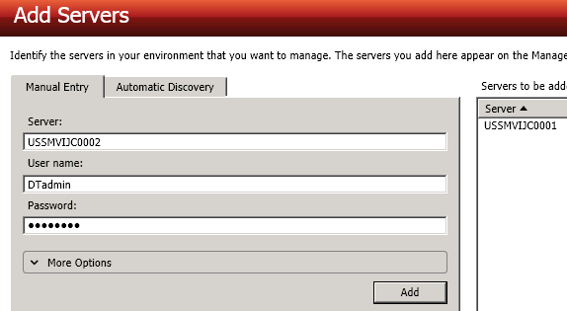

**Click OK** when you see both servers in Servers to be added tab.You will see this in Manage servers screen

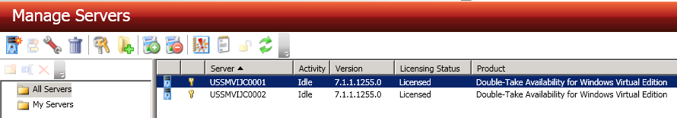

Both servers Activity should be Idle.

Now you can go to Manage jobs, where is replica job available

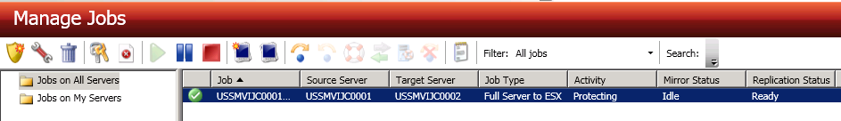

Green tick next to job name means that job is working fine and MII server is being protected. Job Activity should be in Protecting state.

**You are now able to perform Failover.**

# FAILOVER to backup hardware

**FAILOVER TEST CAN BE DONE ONLY WITH APPROVED RFC.**

**YOU HAVE TO RECORD YOUR STEPS WITH TIMES TO THE REPORT PART OF THE CHECK LIST!**

**IJCore will be unavailable until the failover is done.**

**The replica job in Double-take console has to be marked with Green tick.**

**IJCore usage should be stopped at least 30 minutes before Failover, so all messages are processed.**

**This operation cannot be REVERTED!!! Once Failed-over, replica job and IJCore_replica server has to be configured again. This can take up to few hours, depending on disk size and line speed between ESX hosts!**

**Failing over to backup hardware**

1. Once you are sure that all pre-requisites are fine and Plant is not using IJCore anymore, stop IJCore services.

* **Make sure calloffs are not being sent to the server during failover. If you are using EDI server, log on to it and stop application which is sending messages to IJCore. There is a possibility of sequence jump issue.**

1. Shut down primary IJCore server.
2. Logon to VRA server (IJC0002) and start DT console; go to Manage jobs; Right-click on replica job and select Failover or Cutover

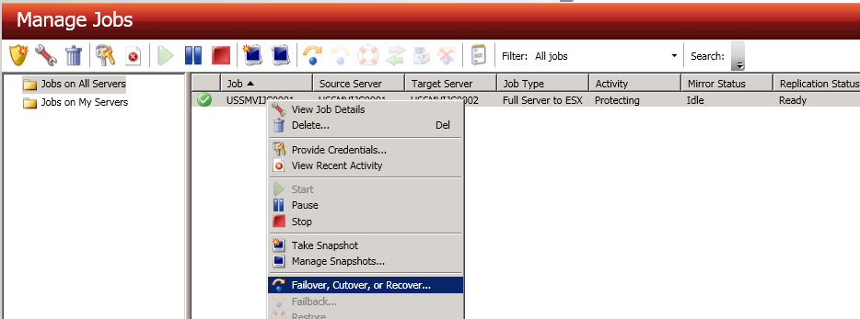

On next screen select Failover to live data and confirm

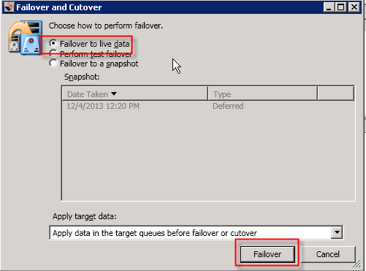

1. During the Failover you can see the activities in DT console

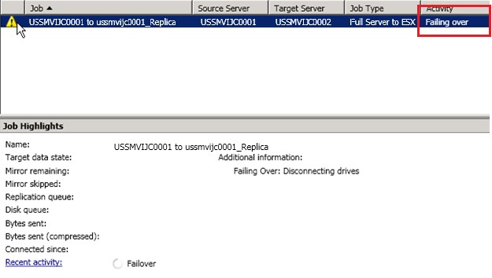

1. When DT console says that the Failover is done, you can check vCenter if IJCore_replica server is booting

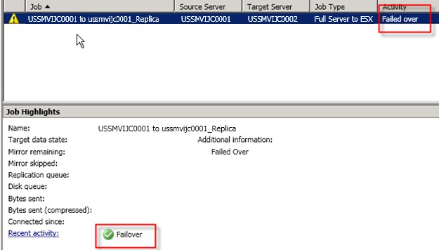

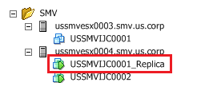

1. Wait before IJCore_replica server is booted. The replica is completely same machine, meaning it has the same Hostname, IP address, etc, etc.
2. Connect to server via ESX console   
   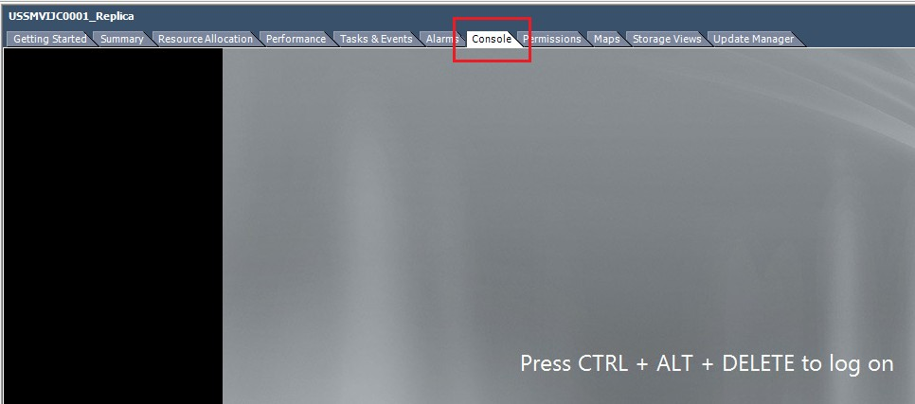
3. Try to ping IP address of Gateway – if it is not successful, follow chapter in known issues. If ok, proceed with next step
4. **Reboot server one more time** (new HW detected)
5. Wait before IJCore_replica server boots again.
6. Log on to it and start IJCore services (they are set to manual startup)

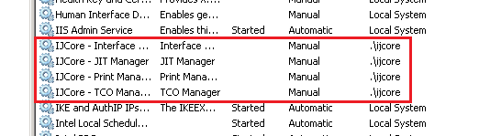

1. **Failover is done now**; you have to test that IJCore works correctly.

vCenter view after Failover. Your original Primary ESX server will become Backup ESX server and vice-versa.

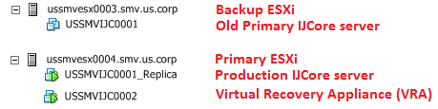

# Tests to be done after Failover

1. Check that IJCore services are running

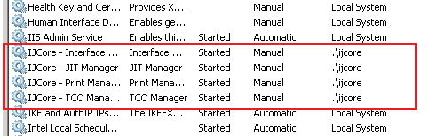

1. If you are using KEPware, check that license is there and it is not in demo mode

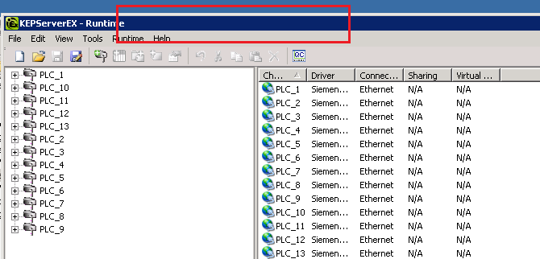

**If it is in demo mode there will be ‘Demo mode expires in: …’ in the red rectangle**

1. Test if you are able to connect to IJCore webmanager

**Test all other functions that plant needs!**

* **Integrate calloffs**
* **Reprint some labels**
* **Check if reports & dashboards are working**
* **Scanners, PLCs, Profaces are connected**
* **…**

**Once done with testing, proceed to the next step!**

# Failback procedure: Re-creating replica after Failover

When the failover is done and Primary IJCore server is running on former Backup ESX, you have to re-create replica job in order to have IJCore_replica server created again. There are few steps that have to be done before actual job creation in Double-take.

1. Connect to RDP of IJC0001 server and delete obsolete Shadow copies for all disks
   1. Shadow copies are snapshots created by Double-take and are obsolete after the failover
   2. You have to delete the Shadow copies manually
      1. Start commandline window
      2. Type in ***wmic*** and press enter
      3. ***wmic:root\cli***is shown
      4. Type in ***shadowcopy*** which will list the current shadow copies
      5. Type in ***shadowcopy delete*** and confirm to delete the copies one after the other
      6. To leave the WMI commandline type ***exit***
2. Go back to your RDP where you performed failover (IJC0002), right-click on replica job and Delete it. 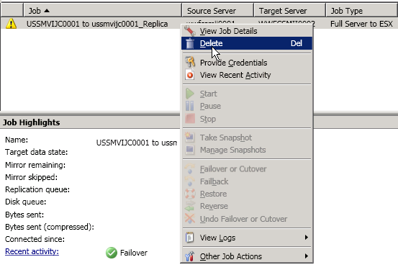
3. Job is deleted in few seconds. Now turn off VRA (IJC0002) server.
4. Migrate VRA (IJC0002) server to Backup ESX

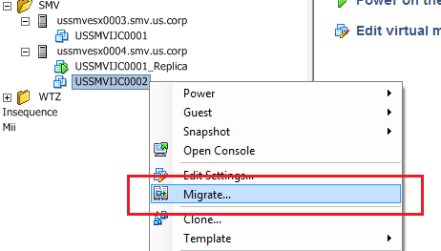

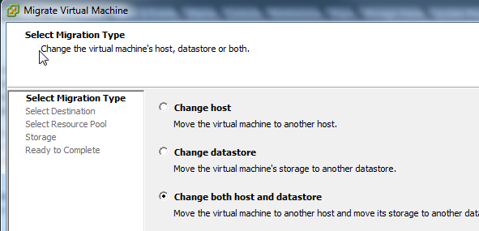

Select Backup ESX

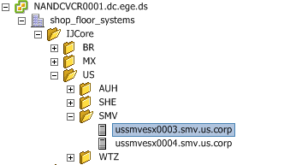

Select appropriate Datastore with _System in name

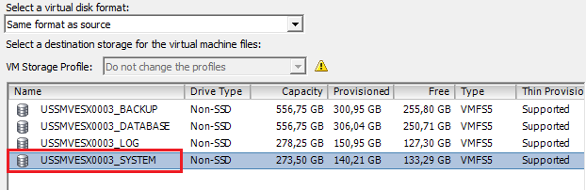

Click next and on next screen finish.

1. When the Migration si done, Power on VRA server IJC0002, check the network for VRA, network label should be CC-SID-SRV

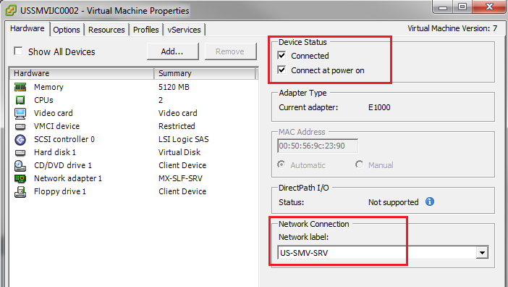

1. Prepare the ESX hosts for the new job by deleting the old production server (In vSphere client Delete XXSIDIJC0001)

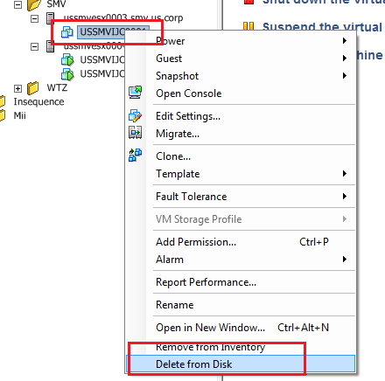

1. Rename IJC0001_replica to IJC0001 (USSMVIJC0001_replica to USSMVIJC0001)
2. Connect to RDP of IJC0002. Start Double-take console. In Manage servers you should see both your servers with Idle Activity.
3. Go to Manage Jobs, press Create a new job and select Double-Take Availability

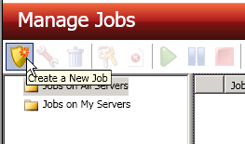 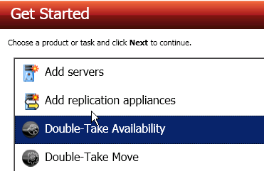

1. Protect files and folders, an application, or an entire Windows server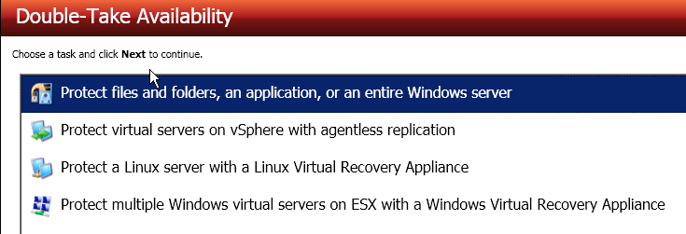
2. Choose server to protect, in our case IJC0001 (USSMVIJC0001)

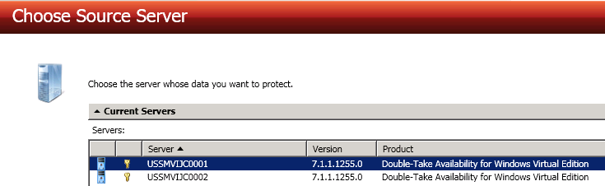

1. Choose Full server to Hyper-V or ESX, check that all Workload items are checked

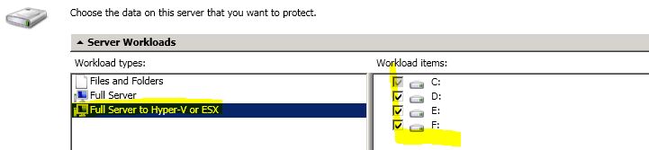

1. Choose VRA server – IJC0002 (USSMVIJC0002)

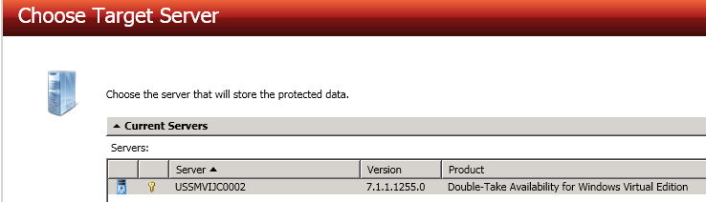

1. fill in target ESX server info (ESX host where VRA server (IJC0002) is located), use IP address! Enter local administrator account name and password

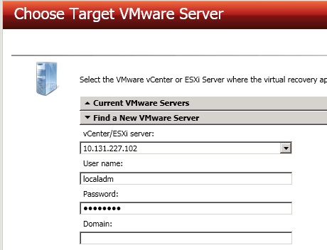

1. Now fill in job options. Name is xxsidijc0001 to xxsidijc0001_replica, in our case ussmvijc0001 to ussmvijc0001_replica

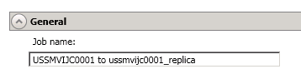

1. Verify Replica Virtual Machine location, it has to be on _System named datastore

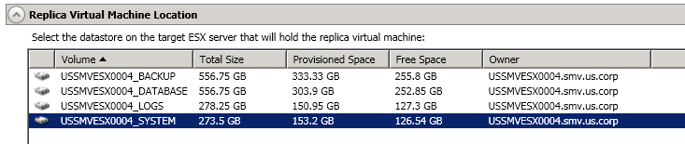

1. Check the Replica Configuration tab, name, CPU & RAM – so the replica has the same resources as prod server; and proper network adapter (should be CC-SSS-SRV – in this case US-SMV-SRV)

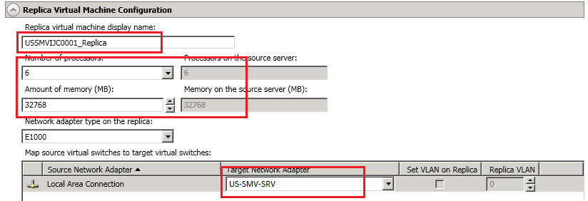

1. Replica Virtual Machine Volumes – ensure that VMDK files are located properly*:
   1. C:\ on _System datastore
   2. D:\ on _Database datastore
   3. E:\ on _Logs datastore
   4. F:\ on _Backup datastore

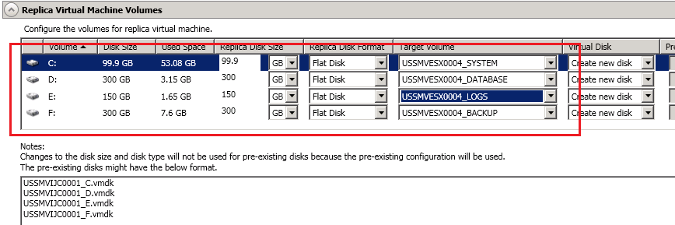

**\* (If you have old configuration with only 2 Datastores (_system and _data) the C:\ will be on _system and D:, E:, F: will be on _data datastore)**

1. In Failover options check that Wait for user to initiate failover is **CHECKED**! 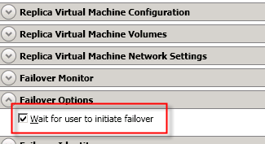
2. Verify that Compression is OFF and Bandwidth is not limited

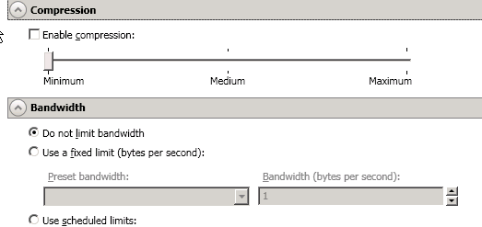

1. Enable snapshots – every 2 hours

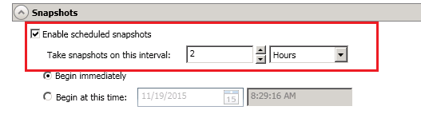

1. Press Next
2. Verify that all check are Green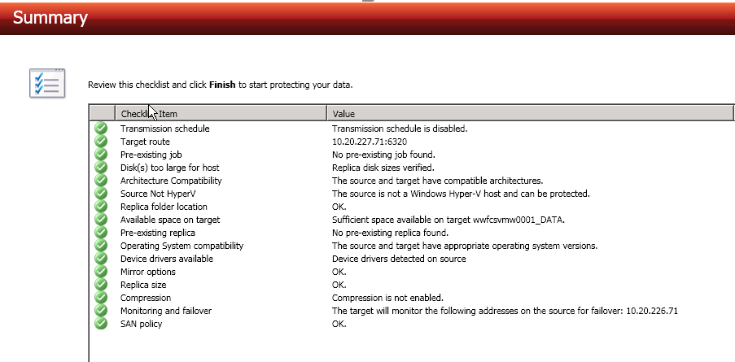
3. Confirm with Finish
4. You will now see the job in Manage jobs, it’s synchronizing the data

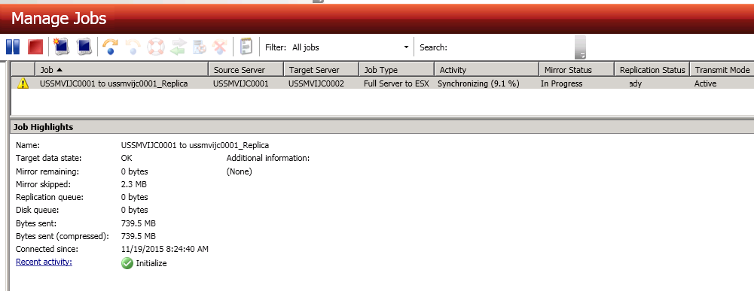

1. Now you need to wait for data replication, and when the status of job changed to Synchronizing, you can continue with next step.
2. You have to set Shadow copy limits on the IJC0002 machine for all mount points
   1. In My Computer right-click C: drive, select Properties. Then go to Shadow copies tab.
   2. Do not set any limit for Volume C – there are no Shadows created on C:
   3. Start with second Volume with label C:\Program Files\Vision...... click Settings.
   4. In settings at the End of Volume line you will see for which drive from IJC0001 this mount point is (see picture below). Set 10% value of the disk size, eg. for 40GB disk set 4096 MB (Check the size of the disk at IJC0001)

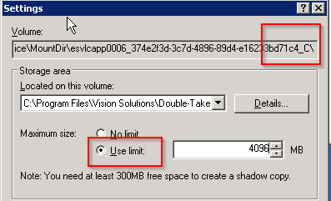

* 1. Confirm and repeat for all mount points. Always use 10% value of the corresponding disk.

1. Wait for the replica to be done – Job is green

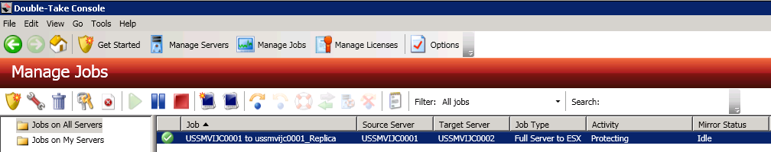

1. **Replica is done, your server is protected again!**

# Summary

This document guided you through failover procedure using Double-take software.

Below you can compare how your servers will look in vCenter view before failover and after failover.

**Before failover (post-installation situation):**



After failover:

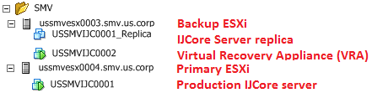

Please always keep in mind that failover should not be done without purpose and has to be properly planned. Always inform 9TECH_IJCore team in advance before failover and request the pre-requisites checklist and report.

In case of any questions of course contact 9TECH_IJCore team again.

# Possible issues

**Replication stops after recreation of DT job**

Sometimes it happens, that after you migrate VRA, and recreate replication job it creates new _replica server but before it starts to synchronize goes into error.

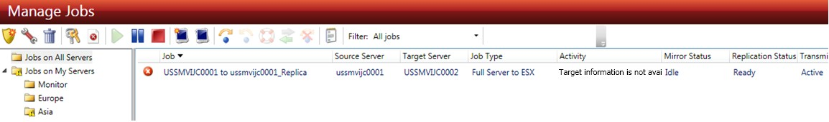

If this happens, just **stop the job and restarts it again**.

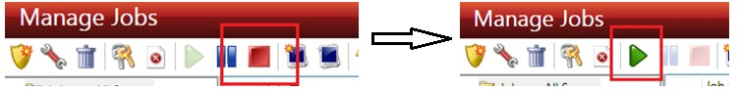

If this doesn’t work, log on with RDP to both Primary and VRA server, open services (start -> run -> services.msc).

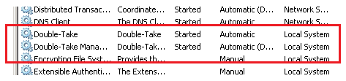

**Stop Double-Take and Double-Take Management Service**. Stop them on both servers; after they are stopped **start them again** on both servers. DT job will restart automatically and start to synchronize automatically.

**Server is not reachable via network after failover**

1. Uninstall network adapter “vmxnet3 Ethernet Adapter”  
   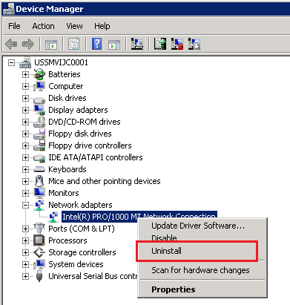
2. Scan for new Hardware  
   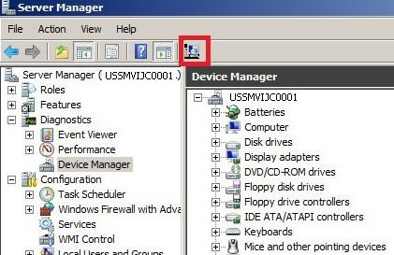
3. Setup network adapter IP address,Mask and gate
4. Test connection by pinging gate IP. If it doesn’t work,repeat steps repeat steps.